**The Role Of Student Community Engagement Participants As Teaching Personnel In Educational Assistance Efforts Through The Smart Village Program In Jejel Village**

**Buyun Khulel, Khoirul Huda, Sinta Zakiyah Maghfiroh, Nur Ziana,**

**Nanda Fitrotun Mukaromah**

Universitas Islam Darul’ulum Lamongan

[buyunkhulel@unisda.ac.id](mailto:buyunkhulel@unisda.ac.id), khoirulhuda@unisda.ac.id

|  |  |  |
| --- | --- | --- |
| **Article History:**  Receive: July 21th 2024  Revised: August 5th 2024  Accepted: August 30th 2024 |  | ***Abstract:*** *The form of community service carried out by students is a real work lecture (KKN). To educate the nation's life, one of the activities that needs to be carried out by KKN students is activities in the field of education. In the implementation of education, of course, it requires teaching staff whose job is to teach, whether teaching in formal or non-formal education. We carried out the Real Work Lecture (KKN) in Jejel Village, Ngimbang District, Lamongan Regency. Our goal of doing KKN in the village is to do community service and help increase interest in learning in the village children. Thus, this article has the title The Role of KKN Students as Teachers in Education Assistance Efforts Through the Smart Village Program in Jejel Village. This Smart Village Program can be carried out well and produces several formal and non-formal education activities, namely being a teacher at PAUD, TK, SD, and TPQ, teaching free tutoring, and providing computer tutoring.* |
| **Keywords:** Community Service, Students, Education. |

**Introduction**

One of the forms of community service carried out by students is Student Community Engagement (SCE). In accordance with the third point contained in the Tri Dharma of Higher Education, namely community service. It is hoped that student service activities can be a driving force in developing applied research that aims to help solve problems in society, apart from that it can develop students' sensitivity to feelings and social conditions (Syardiansah in Hariana, et al, 2021:11).

SCE means directly putting into practice the knowledge received at college in the community. A form of education that provides students with empirical experience of living in society outside campus is the form of SCE, which also directly teaches students how to identify problems that exist in society.

To make the nation's life more intelligent, one of the activities that SCE students need to carry out is activities in the field of education. SCE students are expected to be able to develop various community service activity programs, one of which also touches on educational aspects. One of the locations chosen by Darul 'Ulum Islamic University as a place for SCE is Jejel Village. Jejel Village is one of the villages located in the Ngimbang District, Lamongan Regency, which consists of 3 hamlets heads, 5 RWs, and 15 RTs, with the livelihood of most of the population being farming.

The institution level of education in Jejel village consists of kindergarten/PAUD and elementary school education units. This attracted the attention of our SCE group to help educate children in the village through both formal and non-formal education. According to Law no. 20 of 2002 Article 13 paragraph 1 states that educational pathways consist of formal, non-formal, and informal education.

A number of SCE students are helping the village government or community through several work programs that have been planned. One of them is how SCE students optimize work programs by acting as teaching staff, both teaching in formal and non-formal education in Jejel village. In terms of formal education, SCE participants act as teaching staff in elementary schools, kindergartens, and PAUD. Meanwhile, for non-formal education, SCE participants act as teaching staff through free tutoring programs, computer tutoring, and evening Koran reading.

**Method**

The method of implementing community service activities carried out in Jejel Village, Ngimbang District, is in the form of educational assistance activities, both formal and non-formal. The form of this educational assistance activity is acting as a teaching staff through free tutoring programs, computer study guidance, and evening Koran reading at TPQ. The partners for this activity are residents of Jejel Village, consisting of teachers in PAUD, Kindergarten, Elementary School units and community leaders.

**Results And Discussion**

**The Acticities of SCE**

SCE is a form of community service activity. Our group's SCE implementation is located in Jejel Village, Ngimbang District, Lamongan Regency. Based on 2022 Village Government Administration data, the population of Jejel Village consists of 465 families, with a total of 1,689 people, with details of 864 men and 825 women. The 2023 SCE activity will be carried out for 1 month starting from July 11 to August 10 2023. The service subjects include Jejel State Elementary School, Harapan PAUD and Kindergarten, TPQ, village hall office, rice field area and Posyandu.

One of the community services carried out by our group is through activities in the field of education in Jejel Village, Ngimbang sub-district, Lamongan Regency. The target of the activities to be achieved from the SCE activities in this smart village program is to be able to increase children's interest in learning in Jejel village.

**Realization of Student Roles Through KKN Activities**

In improving quality and overcoming problems that exist in the village where the SCE is located, SCE students can create a program related to that village. Likewise our SCE group plans and realizes work programs related to the problems of Jejel village, namely education. Education in Jejel village can be said to be quite good, but if you look in more detail, there are still students who cannot read and calculate. There are also many students who have low interest in learning. This is what underlies us to act as teaching staff in efforts to assist education in Jejel Village through SCE activities.

1. **Realization of Activities in Formal Education**

SCE students realize work programs in formal education as teaching staff in PAUD, Kindergarten, Elementary School in Jejel Village. The number of teachers in PAUD and Kindergarten is 4 with 80 students, while at SDN Jejel there are 10 teachers and 105 students.

Teaching activities at Harapan PAUD and Kindergarten are carried out 3 times a week, namely on Tuesday, Wednesday and Thursday, every 08.00-10.00 WIB. Acting as a teaching staff in PAUD and Kindergarten has its own challenges for SCE students because PAUD and Kindergarten are education before children enter elementary school.

|  |  |
| --- | --- |
|  |  |

*Figures 1 and 2. Teaching process for PAUD and Kindergarten students*

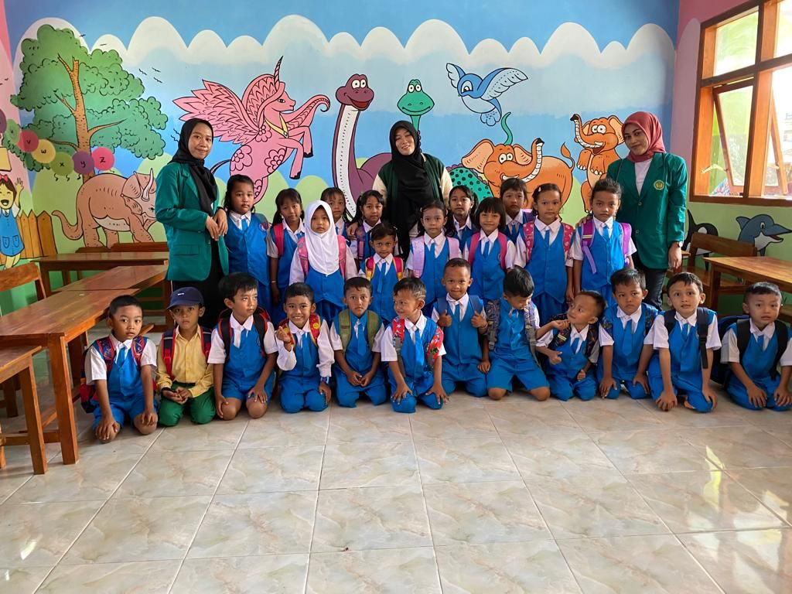

*Figure 3. Group photo of PAUD and Kindergarten Harapan students*

Then the role of SCE students as teaching staff in elementary schools was welcomed by the SDN Jejel school. SCE students are allowed to act as teaching staff at the elementary school by teaching in empty classes. Teaching activities at SDN Jejel are also carried out 3 times a week, namely on Tuesday, Wednesday and Thursday, every 08.00-12.00 WIB. SCE students teach students learning material about counting, from addition to multiplication. Because it turns out there are still many high class students who cannot do multiplication. Here we teach in a very fun way so that students don't get bored quickly when learning, we also often give small rewards to students so that students are more enthusiastic about learning.

|  |  |
| --- | --- |
|  |  |

*Figures 4 and 5. Teaching process at SDN Jejel*

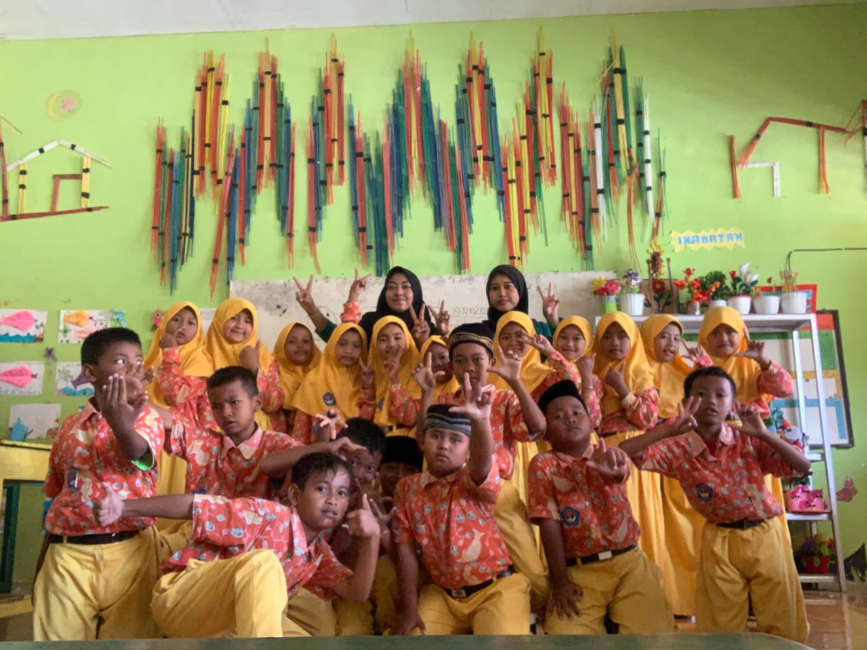

*Figure 6. Group photo of Jejel Elementary School students*

1. **Realization of Activities in Non-Formal Education**

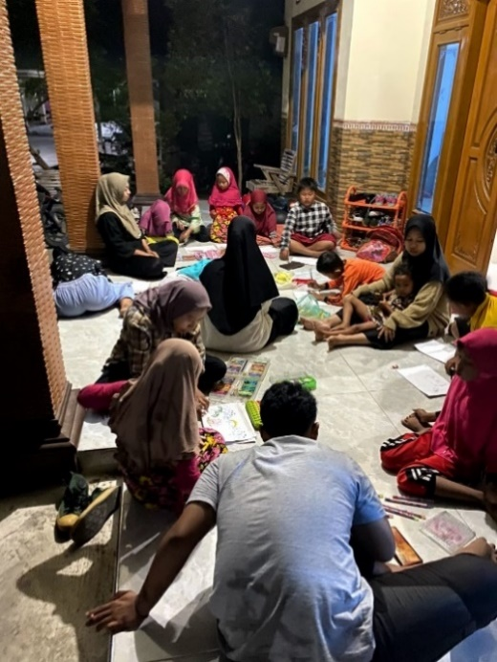Apart from acting as teaching staff in formal education, SCE students also act as teaching staff in non-formal education activities such as teaching tutoring for free, providing computer study guidance, and teaching the Al-Qur’an at TPQ. Based on the information obtained during observations, it can be seen that Jejel Village still does not have teaching staff in the field of courses or tutoring. Therefore, our group of SCE students planned and implemented a free tutoring or tutoring work program. This free tutoring activity is held after sunset, Monday to Thursday at the SCE post. The material we teach is addition, subtraction, multiplication using mathematics, division, English, and also learning to read, because there are still children who cannot read.

*Figure 7. Tutoring activities with Jejel Village children at the SCE post*

Not only that, we also provide computer study guidance. This activity aims to broaden the knowledge of children who are just starting to get to know the digital world so that they do not use the digital world for negative things. This computer tutoring activity is also held after sunset, on Friday and Saturday. The material we teach is how to turn on, turn off, open applications, type, create paragraphs, adjust writing position, and tidy up sentences. Then we carry out TPQ teaching activities from Monday to Sunday, and we divide them into teaching TPQ in 3 hamlets, namely Jejel, Galeh and Sayun hamlets. Teaching TPQ (Al-Qur'an Education Park) for children in Jejel Village aims to provide religious education and learning the Al-Qur'an from an early age. This can help strengthen understanding of religion, moral values ​​and Islamic ethics as well as introduce tajwid to the younger generation in the village environment. Apart from that, teaching TPQ can also help preserve cultural and religious traditions.

|  |  |
| --- | --- |
|  |  |

*Figure 8 and 9. Computer tutoring activities and reciting Al-Qur’an activities at TPQ Jejel Village*

**Conclusion**

The conclusion from the title of this article is that the 18 students involved in the SCE Program have an important role as teaching staff in supporting educational assistance efforts through the Smart Village Program in Jejel Village. This shows that through this collaboration, students can help improve the quality of education in Jejel village. Also, the role of students in helping teach at PAUD, Kindergarten, Elementary School, and TPQ as well as helping teach computers to the children of Jejel Village is very meaningful in improving the quality of education at the elementary level. Their involvement can have a positive impact on the learning and development of children in the village.

The programs that have been realized by the students have received good evaluations from the village community, the school principal, and all teaching staff, as well as the village government. They were very happy and helped by the presence of KKN students who played a role in the village. This is proven by the community's great desire and enthusiasm to welcome KKN students back to Jejel village.

**Acknowledgement**

We would like to express our thanks to the people of Jejel village, especially to Mr. Ja'in (the Head of Jejel Village), Mr. Darpin (the village secretary), and all Village officials who have fully helped and supported the planned programs so that the entire series of SCE activities in Jejel village took place well and able to contribute to the village community. We would also like to thank the SCE supervisor, namely Mr. Buyun Khulel M, Pd, and also the Unisda SCE committees for their assistance and cooperation in making this community service activity a success.

**References**

Aliyyah, R. R. (2021). KULIAH KERJA NYATA: PENGABDIAN KEPADA MASYARAKAT. *JMM (Jurnal Masyarakat Mandiri), 5*, 663-676.

Hariana, d. (2021). Peran Mahasiswa KKN dalam Melaksanakan Kegiatan Tambahan di Lokasi Pengabdian Desa Botuwombato. *JAT, 1*, 10 – 16.

Hasanah, U. (2022). OPTIMALISASI PERAN MAHASISWA KKN SEBAGAI TENAGA. *MARTABE : Jurnal Pengabdian Masyarakat, 5*, 3275-3283.

Kemal, I. (2022). MENINGKATKAN PENDIDIKAN PROSES BELAJAR MENGAJAR ANAK-ANAK DI KELURAHAN NELAYAN INDAH KECAMATAN LABUHAN. *Reswara : Jurnal Pengabdian Kepada Masyarakat, 3*, 634-640.

Megawati, N. (2023). PERAN MAHASISWA KULIAH KERJA NYATA (KKN) DALAM BIDANG. *Jurnal Pengabdian Kepada Masyarakat, 2*, 204-208.

Novia Aisah Asriati, d. (2021). Peran Mahasiswa KKN Dalam Bidang Pendidikan Di. *Proceedings UIN Sunan Gunung Djati Bandung, 1*, 141-155.

Umar, A. U. (2021). Peranan Kuliah Kerja Nyata Sebagai Wujud Pengabdian Kepada Masyarakat Di Tengah Pandemi Covid-19. *E-Amal: Jurnal Pengabdian Kepada Masyarakat, 1*, 39–44.

Y., N. K. (2019). Peran Mahasiswa Dalam Meningkatkan Pendidikan Di Desa Cibanteng. *Abdi Dosen : Jurnal Pengabdian Pada Masyarakat*, 401.